From hip hop to identity appropriation

Disco, hip hop, sampling
By the second half of the century, recording is the major focus of popular music as an industry. Recordings and technology become important areas for appropriation.
Because records are mass-produced, more permanent than live performance, and major sources of wealth that are subject to copyright, legal and ethical questions about appropriation become more central.

Technology and Appropriation
- Disco re-edits (1970s – ) [tape recorders]
- Remixes (1970s – ) [recording studio]
- Hip hop DJing (1970s – ) [turntables]
- Sampling and producer music (1980s – ) [samplers, studios, computers]
- Mashups (1990s – ) [computers]

Disco and hip hop djing
Disco djs developed the method of extending a song by having two turntables with a copy of the same record on each.
When rap began in the 1970s, the most common practice was to accompany the rap with breakbeats. The DJ would have two copies of the same record – one on each turntable .
He would cut back and forth between an instrumental or percussive interlude in the song (the “breakdown”) and the same instrumental passage on the other disc, creating a continuous stream of the same rhythm line for the MC to rap over.
DJ Hollywood and Love Bug Starski live at The Armory (Bronx), 1979
http://www.youtube.com/watch?v=EqLL9Tw2i6c
Kool Herc
http://www.youtube.com/watch?v=7qwml-F7zKQ
Breaks, Needle Dropping, Scratching
http://www.youtube.com/watch?v=wNwPEILfL1M

Appropriation in early hip hop
- Initially hip hop was not commercial in our sense; typically practised in recreation centres, outdoors in schoolyards and on the street; improvisational; for pleasure
- DJs used (almost exclusively black) records (dance, funk, and r&b), which they mixed together to create extended breakbeat backdrops for b-boys and b-girls to dance to
- Eventually members of the crew or the DJs themselves started to rap over the breaks
- These were “amateur” public performances, for small cover charges, largely unrecorded, in which old and new records (funk, soul, jazz and disco) were used as sources for original musical experiences.

A few resources for early hip hop
Books
Jeff Chang, Can’t Stop Won’t Stop: A History of the Hip-Hop Generation (2005)
Jim Fricke and Charlie Ahearn, Yes Yes Y’all: The Experience Music Project Oral History Of Hip-hop’s First Decade (2002)
Ed Piskor, Hip Hop Family Tree (2013) (comic) several volumes have appeared so far
Films
Wild Style (1983) Docu-drama with rare footage of early hip hop acts and graffiti artists. (sometimes can be seen in its entirety on YouTube; many clips always there)
And you don’t stop: 30 years of hip hop (2004)
Beat This: A Hip Hop History (1984)

Early hip hop
“Jes’ grew”
A new form of collaboratively authored “urban folk music.”
It is only with recording and sampling that legal (and political or moral) questions of appropriation become central to hip hop practice.

Blondie – hi hop promoter
Punk singer Debbie Harry, aka Blondie, was into the underground hip-hop scene in the late 70s and it was she who invited members of Chic to a Sugarhill Gang event, which is how they knew who the Gang was when members jumped up onstage and started improvising raps over “Good Times” at a Chic concert a few weeks later.
The first mainstream rap single was Sugarhill Gang’s “Rapper’s Delight.” It uses an instrumental cover of Chic’s disco hit “Good Times” from the same year as the accompaniment. It was the first time a band (Chic) demanded remuneration from a hip hop artist for using their music with the artists’ rapping.
http://www.youtube.com/watch?v=diiL9bqvalo
It was also the first known example of a Sample replay. The Sugarhill Gang got studio musicians to re-record an extended instrumental of the Chic song for them to rap over.

Rap hits vinyl and the charts
The first mainstream rap single was Sugarhill Gang’s “Rapper’s Delight.” It uses an instrumental cover of Chic’s disco hit “Good Times” from the same year as the accompaniment.
“Rapper’s Delight” is a 12” single. It’s about 15 minutes long. It was the bestselling 12” single to that time.

Sample replay
The hip hop artist gets a group of musicians to replay the music they want to use in the style of the original track.
Now they only have to get permission from the publisher of the music, not from the record label or owner of copyright on the original recording…

Hip hop originally a live, night-long happening
Chuck D, later of Public Enemy, remembers when “Rapper’s Delight” appeared how strange the idea of recording hip hop seemed back then.
“I’m like, record? Fuck, how you gon’ put hip-hop onto a record? ‘Cause it was a whole gig, you know? How you gon’ put three hours on a record?” Chuck says. “Bam! They made ‘Rapper’s Delight.’ And the ironic twist is not how long that record was, but how short it was. I’m thinking, ‘Man, they cut that shit down to fifteen minutes?’ It was a miracle.” (quoted in Jeff Chang, Can’t Stop, Won’t Stop)

Blondie, “Rapture” (1981)
The first #1 “rap” single was actually by Blondie!
http://www.youtube.com/watch?v=pHCdS7O248g
- Earliest white appropriation of hip-hop
- Very rare early female rapper (not the first)
- The first #1 single to feature rap
- The first “rap” video to be broadcast on MTV; one of the first ever (1st day of MTV)
- Features cameos by rapper and graffiti artist Fab Five Freddy and graffiti artists Lee Quinones and Jean-Michel Basquiat.
- Grandmaster Flash was supposed to appear, but didn’t show for the video shoot.
- However, he used the song in his famous mix “Adventures of Grandmaster Flash on the Wheels of steel ”
- Incidentally, “Rapture” doesn’t use music appropriation or hip hop djing. They wrote an original tune for the song.
- You could say it is inspired by hip hop, rather than a genuine rap song.

Sampling (1980s)
Gradually through the 1980s the live dj tends to be replaced by canned backing tracks, usually based on sampled breaks, programmed drum machine beats, and commercially produced loops sold for this purpose.
One hour BBC radio documentary on the Amen break: http://www.youtube.com/watch?v=BIBU6lEs0u4
In one of this week’s assigned reading, Chuck D and Hank Shocklee from Public Enemy are asked about how hip hop was changed by the rise of mandatory licensing of samples.
In the interview, how do they suggest that sampling clearance changed hip hop?
http://www.stayfreemagazine.org/archives/20/public_enemy.html

Grand Upright Music, Ltd. v. Warner Bros. Records Inc.

Gilbert O’Sullivan sues Biz Markie for unauthorized use of “Alone Again (Naturally)” – changes hip hop forever…
http://www.youtube.com/watch?v=LsAjmtKLz2M

Performance appropriation
The unprecedented form of appropriation that became possible in the 20th century due to audio and video recording, in which a human being’s performance can be appropriated, distorted (or not), and used by another human being as part of their performance.
We tend to think of this in terms of intellectual property and money, but what is the human impact of performance appropriation?
Performance appropriation takes off when hip hop djs start live-mixing old records to create original music. The (mostly instrumental) performances become part of a new song and eventually the backing track for new vocal performances (rap).
With sampling in the 1980s, performance appropriation becomes common. Dead musicians play along with living ones in new musical pieces. An example I’ve mentioned several times is Ray Charles singing behind Kanye on “Golddigger.” The appropriated performer need not be dead. The Police play along with Puff Daddy on “I’ll be missing you” – no doubt they were happy to be sampled (and paid) but their performance has thus been appropriated.
Performance appropriation seems most questionable, though, when one of the performers is dead and has no control over what is done with their performance.
With new innovations in digital editing and computer animation, people’s video performances can also now be appropriated and manipulated. My favourite example is the so-called “Tupac hologram,” which I discuss below, under the related phenomenon of “Identity Appropriation” …
Other examples of performance appropriations of dead celebrities:
Gene Kelly breakdances for Volkswagen.
Audrey Hepburn dances for The Gap.
Audrey Hepburn’s original dance in 1957′s Funny Face.

Identity Appropriation
“Who owns you when you’re dead?”
With the increase in the sophistication and prevalence of digital recording, more and more aspects of our lives are becoming recordable and open to manipulation. The reanimation of dead celebrities in advertising may be the tip of an iceberg of identity appropriations that will involve life-like recreations – and perversions – not just of celebrity personalities, but ultimately of any of us. Imagine grandma dies and then a robot or hologram grandma replaces her in her favourite chair …

2pac 2.0
Tupac Shakur (1971-1996) recreated as a “hologram” at Coachella (2012)
In “All Eyez on Me” Tupac sang “Live the life of a thug, until the day I die
/ Live the life of a boss playa.”
But what happens to him AFTER he dies? Do the dead have any rights? Can their identities be appropriated, their performances recreated and changed and used in new contexts, can their personalities be perpetuated through technology and continue to develop even though the person is dead?
These are questions for which there seems to be no legal precedents and little moral discussion so far.
Dr Dre paid for and presumably “owns” the Tupac hologram. Tupac’s mother gave him permission to create it. (Though it’s not at all clear that she really had the right to give that permission.)
Can Dr Dre now sell the hologram to other interested parties?
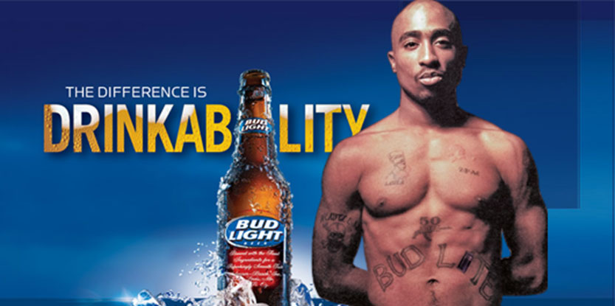
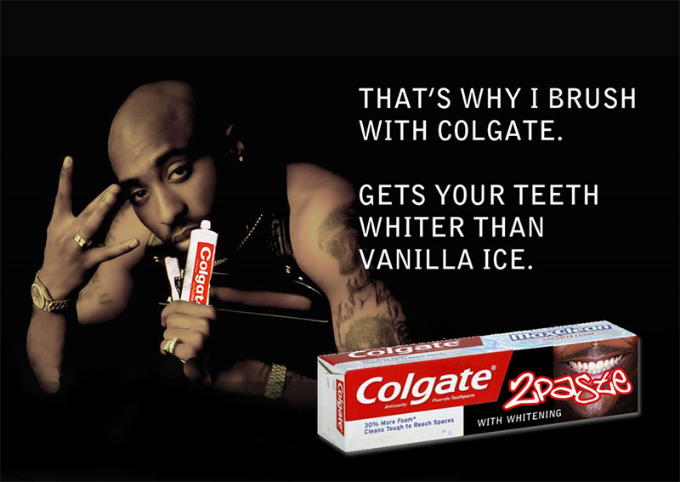
These are fanciful conceptions, but does anything really make this different from Audrey Hepburn advertising Gap pants she never wore, or chocolate she never ate in real life.

Capitalist appropriation, postmodern decontextualization, and identity appropriation
- Does the original context matter? To the remixer? To the audience?
- Is the original context even known? To the remixer? To the audience?
- Should the original artist have any “rights,” even if they are dead?
No one cares about the original creators or the original context in which the work was created or presented.
- The intentions of the film maker or the scriptwriter
- What the choreographer was trying to do with the dance
- Who Audrey Hepburn thought she was when doing the dance – what either Audrey Hepburn’s character or Audrey Hepburn herself was dancing for
- The intentions of AC/DC in writing and performing their song
- Whether any of those people would like to be associated with each other or would like to promote The Gap
Or, in the case of Lil Wayne’s track “Six foot, seven foot,” produced by Bangladesh.
- The meaning or intentions of the anonymous banana workers
- The meaning or intentions, feelings or values of Harry Belafonte

Why might it be good for a remixer and their audience to understand the appropriated material in its original context?
- Because this shows the respect and understanding of the original creator that the remixer would probably like for their own work.
- Because the experience of the new work is richer and more multidimensional if the meanings, feelings, and context of the original operate as part of the new context.
- Because if the audience does understand the context of the original work, but the remixer doesn’t or ignores it, the audience may get a different message or have a different experience than the remixer intended.
What do appropriators owe to the creators of the past?
- Nothing
- Royalties
- Acknowledgement
- Respect
- Knowledge, true understanding

