Due in class on Oct 14. Please and then print out this document, or write your answers on separate sheets, and hand in your answers in class on Friday Oct 14. You must be present in class on Friday Oct 14 and prepared to discuss your answers to receive full marks on this assignment
- What was the original term of copyright in Great Britain, also adopted by the United States in its early years? What is the current term of copyright in the U.S.? In Canada?
- Explain what is meant by Fair Use (called Fair Dealing in Canada)
- When Cory Doctorow says that developing countries need a copyright policy like the United States had in 1776 what does he mean?
- Why does the film end in Brazil?
- What do the filmmakers mean by copyleft? Why do you think they called it “copyleft”?
- What was Girl Talk’s day job, and why was it relevant to the argument made in the documentary?
- Watch the segment with this guy a couple of times (it starts around 64 minutes into the film). What is he saying about the state of the deal the U.S. made based on the idea that the developed world would employ people in an ideas-based economy, while the developing world took over manufacturing jobs?
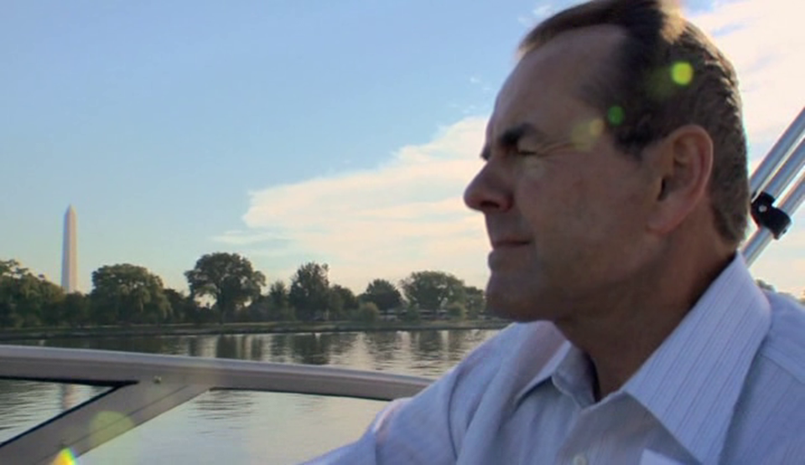
- Read the assigned reading by Negativland (http://remixculture.ca/remix/docs/negativland.pdf). If you have limited time, just read the last three pages, starting with the section “A DIFFERENT VALUE” on page 260. What changes to the laws around “fair use” are Negativland proposing we should make?
- Try to define each of the following practices where copyright infringement might take place, in such a way as to make clear what distinguishes them from each other. Think about who does them, why, etc.
a. PLAGIARISM
b. SAMPLING
c. PIRACY
d. FILE SHARING

