Culture Jam Assignment (5 marks)
We will be looking at a selection of these in class. Your culture jam must be live in the forums by start of class on Friday to receive credit for this assignment. You must also be in class and prepared to discuss your jam to receive full credit.
A culture jam uses the media of a dominant culture (corporate, entertainment, political) to criticize and subvert the intentions or values of that culture.
Dominant (mainstream, hegemonic, commercial) culture generally aims to seduce and entertain you; culture jams typically want to disrupt or upset you, make you feel uncomfortable about the elements of mainstream or dominant culture that they are subverting.
Here is an example. This was done by a student in a previous class as her Creative Remix Project:
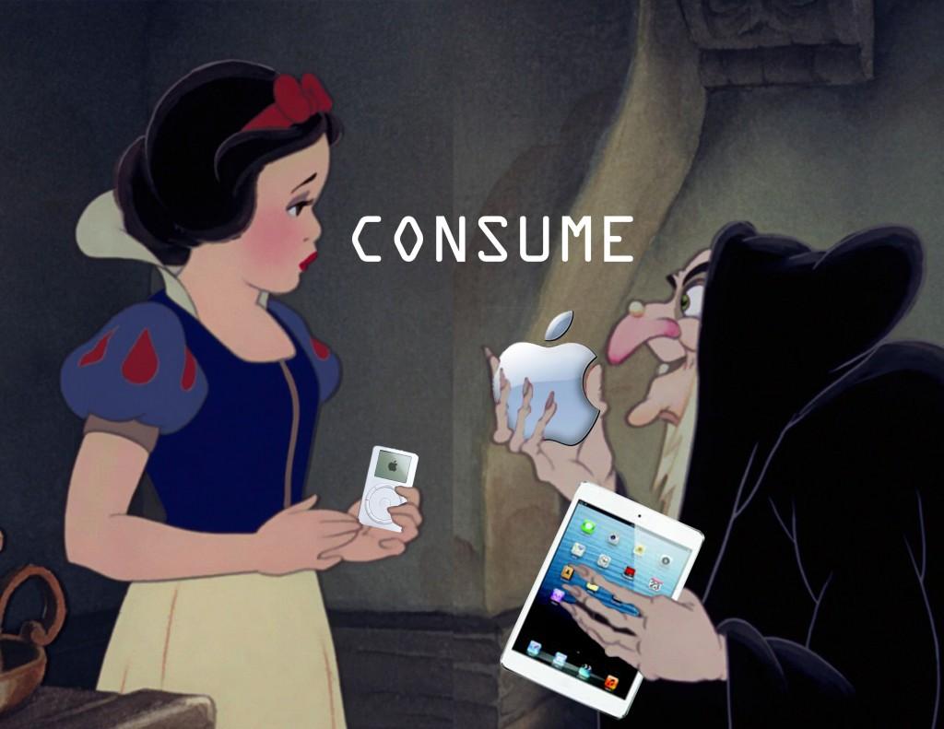
The image appropriates from Disney and Apple to create a new message about consumption, specifically Apple products.
Culture jams may be audio, video, or still images, and could possibly exist in other modes as well.
The term culture jamming was coined by Negativland. You may remember them being featured in Rip! A Remix Manifesto, and they were the authors of the tie-in article that nobody read.
You can find more information about this type of appropriation in the review notes for Participatory Culture, Video Mashups, Culture Jamming.
Your assignment:
Find an example of culture jamming – an image, a video, an audio file, etc – on the Web and link to it (or upload one that you already know about or create yourself). It must use appropriation and critique dominant culture.
Go to the course Blackboard site’s discussion board and go into the Culture Jam forum. (Course tools / Discussion board / Culture Jam Assignment). Create a new thread and in your thread please embed, attach, or link to the culture jam you wish to discuss. Write a paragraph introducing the culture jam to the class.
If you have questions or concerns please email me.
Have fun!

